11/2/2023

[company name]

ICS 2204

Introduction to computer and data processing

CHRISPINA GIFT JOHN HSB213-0060/2022

HILLARY OCHIENG HSB214-0122/2022

LINA JELIMO HSB213-0062/2022

# There are different types of flowers, some popular ones include;

1. Lilies
2. Daffodils
3. Sunflowers
4. Orchids
5. Carnations

SS 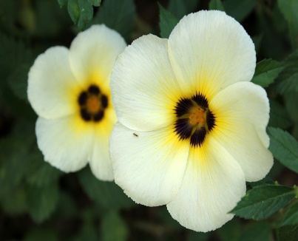 Flowers are of importance to the nature, they add colour, texture and biodiversity to gardens and ecosystems. They are also botanically important and essential sources of food for many organisms. Flowers are important means of attracting pollinators to a plant which is necessary for the plant to produce seeds necessary for germination.

Sunflowers thrive in places with abundant sunlight and well drained soil.

The importance of flowers in nature is crucial as without flowers there would be no fruits, grains, nuts or berries as these are ripened products of a successfully fertilized flower. These foods are also critical sources of calories and nutrients for a wide variety of organisms.

Dried flowers and plant parts are used for teas and infusions. Teas are useful for relaxation as well as medicinal benefits. Flowers also signify strength, purity and consciousness. Examples of flowers used in tea;

* Lavender
* Rose
* Jasmine
* Hibiscus
* Marigold

There are also some interesting facts about flowers; some flowers are carnivorous and trap insects to digest them. Other flowers can hear buzzing bees and some are natural insecticides. Flowers are thermogenic and can generate heat to attract pollinators.

Herbs are leafy green or flowering parts of a plant (either fresh or dried ). Herbs are rich in antioxidants especially cloves, cinnamon, sage, oregano and thyme by helping to reduce low density lipoproteins (‘bad’ cholesterol). Some examples of commonly used herbs are as follows;

|  |  |  |  |
| --- | --- | --- | --- |
| Number | Name | Scientific name | Uses |
| 1 | Rosemary | Salvia rosmarinus | Used for poultry lamb and soup |
| 2 | Cinamon | Cinnamomum verum | Lowers blood sugar level |
| 3 | Basil | Ocimum basilicum | Adds flavour to meals |
| 4. | Mint | Mentha | Prevents cancer and obesity |
| 5. | Coriander | Coriandrum sativum | Incorporated in food during cooking |

Ammonium, (NH4)+  is an important source of nitrogen for plants. It is taken up by plant cells via ammonium transporters. 